MANUFACTURED LANDSCAPES
Matthew Albanese, Jude Broughan, KangHee Kim and Jeffrey Milstein
February 20- April 5, 2025
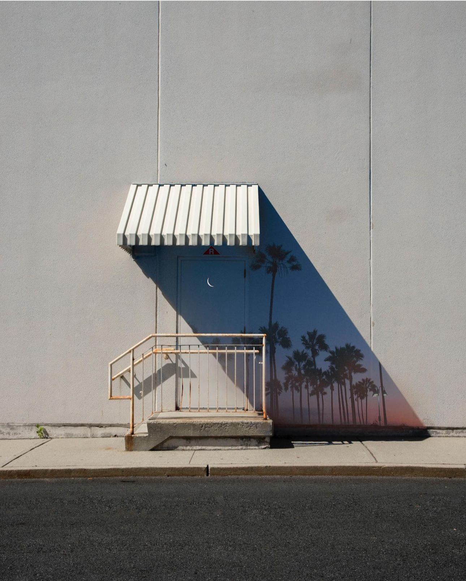
Benrubi Gallery is please to present a Winter Group Show organized around the idea of the Manufactured Landscape. One could consider the “Manufactured Landscape” to be a norm of our modern world, which it absolutely is, and it is not a new concept for photographers to explore either. It is in this vein that we seek to see what an idea made into a household phrase with the work of Edward Burtynsky in a 2006 world looks like now.
We have changed in so many ways since the now seemingly halcyon days of a pre-2008, pre-pandemic society. We have come to fully inhabit our digital spaces, and whereas the integration of technology into fine art was always inevitable, and photography has always been a medium of change, we must still highlight where those changes live and how they are being executed and why.
Four gallery artists: Matthew Albanese, Jude Broughan, Kang Hee Kim, and Jeffrey Milstein all using various methods to create these narratives within their picture spaces offer an investigation into the idea of what a Manufactured Landscape in 2025 is. From the use of the intricate diorama to the reappropriation and integration of slices of life, to the use of photoshop as the cardinal gesture of the composition, and Milstein’s use of pure optics to disturb and disrupt, allowing the viewer to question the very nature of their own perception. This is where we find ourselves at the juncture of what is the gesture of the hand and what is engineered, a synthetic reality that at its most impactful is now something we are quite comfortable with. We are even comfortable with the new awareness that we may not know. We find ourselves fluent in the language of what creates these disruptions of perspective, and we find perhaps they are not so disruptive anymore, they are simply our world at this time, in this place.

For press and other inquiries, please email: info@benrubigallery.com

