DENNIS POWERS: Landscapes Notices
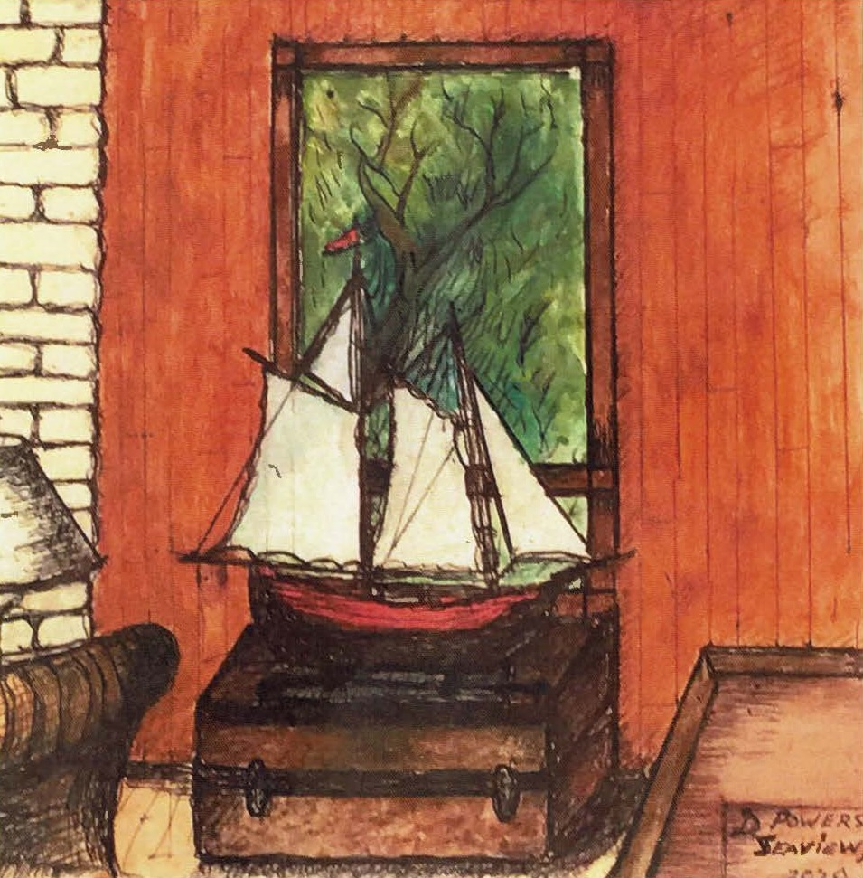
January 25- February 15, 2025
Benrubi Gallery is pleased to present “Landscapes Noticed,” a solo exhibition of works on paper by Dennis Powers. A collection of exquisitely rendered views that reveal to us the artist’s gaze unto a rapidly changing world; a world rattled by climate change, and a complimentary inward turn to the life of the interior. The two are meditations on the scenes that make up our days. These are the slices of life that determine the course of our lives, our internal and external selves. Our inner monologues, the spaces that hold us close and the landscapes beyond our walls where the eternal rhythm of change and motion is the one constant.
For Powers weather and all its infinite influence at this juncture of humanity plays a vital role in how he sees the natural world and its subsequent collision with the man made. The turbulence of wind, the heat of a summer’s day, the clouds crossing our sky, the brilliant drama of natural motion is critical to his gestural brushstroke. He then applies this to the domestic world where a floral still life becomes a record not just of the ever changing external but a meditation on line and all its possibilities for expression.
Dennis Powers has been an integral member of the Benrubi Gallery since it’s very inception and we are honored to celebrate his work. His practice has been a life’s journey, and the seeds of these works were planted in the 90’s followed by a period of intensive focus beginning in 2010 through the present day.
In 1980, following a career in advertising and Corporate Communications, Dennis started his own production company to direct and produce documentary films and commercials for television, as well as corporate videos. Dennis has produced and/or directed many award-winning TV commercials and films including an hour-long documentary for American Masters Television on The Actor's Studio, featuring Paul Newman, Joanne Woodward, Eli Wallach, Ellen Burstyn, Harvey Keitel, Lee Grant and Norman Mailer; a PBS documentary on Andrew Wyeth's the Helga Pictures, featuring Charlton Heston; and, several award-winning documentaries for the Boys' Club of New York, The University of Virginia, Boys Hope Girls Hope of New York, and The New York Historical Society.
Dennis was awarded a New York Emmy for his work as director on a project for Gallery HD titled Aperture, featuring Catherine Chalmers and Rosario Dawson. As Director/Producer he has also received awards from the New York Film Festival, the Chicago Film Festival, The Clio Awards, the Houston Film Festival, the Venice Film Festival, and the Cannes Film Festival.
In 1987 Dennis married Bonni Benrubi, who established the Bonni Benrubi Photography Gallery in New York City. They have two sons, Sam and Jack. Bonni passed in 2012 after a long battle with lung cancer. The Benrubi Gallery continues to flourish in the Chelsea area of New York City.
For press and other inquiries, please email: info@benrubigallery.com

